ER P3 (23 CCR Section 5007) Protect Opportunities to Restore Habitat
- Within the priority habitat restoration areas depicted in Appendix 5, significant adverse impacts to the opportunity to restore habitat as descripted in section 5006, must be avoided or mitigated.
- Impacts referenced in subsection (a) will be deemed to be avoided or mitigated if the project is designed and implemented so that it will not preclude or otherwise interfere with the ability to restore habitat as described in section 5006.
- Impacts referenced in subsection (a) shall be mitigated to a point where the impacts have no significant effect on the opportunity to restore habitat as described in section 5006. Mitigation shall be determined, in consultation with the California Department of Fish and Wildlife, considering the size of the area impacted by the covered action and the type and value of habitat that could be restored on that area, taking into account existing and proposed restoration plans, landscape attributes, the elevation map shown in Appendix 4, and other relevant information about habitat restoration opportunities of the area.
- For purposes of Water Code Section 85057.5(a)(3) and Section 5001(j)(1)(E) of this Chapter, this policy covers a proposed action in the priority habitat restoration areas depicted in Appendix 5. It does not cover proposed actions outside those areas.
The Delta Plan’s Ecosystem Restoration Policy 3 is applicable to the Yolo Bypass Salmonid Habitat Restoration and Fish Passage Project (Project) since the Project will utilize flowage easements within the legal Delta portion of the Yolo Bypass priority habitat restoration area, as depicted in Appendix 5 of the Delta Plan (DSC 2013; Figure 1).

The Project operations within the legal Delta are consistent with this policy, as the goal of the Project is to restore habitat and fish passage opportunities for adult and juvenile salmonids and sturgeon in the Yolo Bypass. The Project purpose statement is listed below, that details how the Project will aid in habitat restoration within the Yolo Bypass.

All significant adverse impacts to sensitive species and habitats will be mitigated to less than significant with implementation of the Mitigation Monitoring and Reporting Program that was finalized with this Project’s Final Environmental Impact Statement/Environmental Impact Report (DWR and USBR 2019). DWR is seeking a Project-specific Incidental Take Permit in consultation with the California Department of Fish and Wildlife and will fully mitigate all impacts of the Project.

Project Purpose
The primary purpose of the Project is to achieve the intent of the National Marine Fisheries Service’s Biological Opinion (2009 NMFS BO) RPA actions I.6.1 and I.7, which were carried forward as baseline conditions in the new Biological Opinion on Long Term Operation of the Central Valley Project and the State Water Project issued by NMFS on October 21, 2019 (2019 NMFS BO). The 2019 NMFS BO includes the Proposed Project under Reasonable and Prudent Measure (RPM) 1(g). The actions are also required under Section 9.2.2 of the Incidental Take Permit for Long-Term Operation of the State Water Project in the Sacramento-San Joaquin Delta (2081-2019-066-00) (LTO ITP), issued March 31, 2020, by the California Department of Fish and Wildlife. The Project would implement those requirements by creating a better hydraulic connection between the Sacramento River and the Yolo Bypass. The Project would allow increased flow from the Sacramento River to enter the Yolo Bypass through a gated notch on the east side of the Fremont Weir. The gated notch would create an opening in the Fremont Weir that is deeper than the Fremont Weir, with gates to control water going through the facility into the Yolo Bypass. The invert of the new notch would be at an elevation of 14 feet, which is approximately 18 feet below the crest of the existing Fremont Weir. From November to March 15, water would be able to flow through the notch during periods when Sacramento River elevations are greater than 14 feet. After March 15, Project flows will be limited to prevent additional inundation from the Project.

The Project would connect the new, gated notch to Tule Pond with a channel that parallels the existing east levee of the Yolo Bypass. It would allow flows up to 6,000 cfs, depending on Sacramento River elevation, through the gated notch to provide open channel flow for adult fish passage, access to floodplain rearing habitat, and additional floodplain inundation. This Project would include a supplemental fish passage facility on the west side of the Fremont Weir and improvements to allow fish to pass through Agricultural Road Crossing 1 and the channel north of Agricultural Road Crossing 1.

The Project would implement the 2019 NMFS BO RPM 1(g) and minimize SWP and CVP impacts to fish growth and survival by:
- Increasing the availability of floodplain fisheries rearing habitat for juvenile Sacramento River winter-run Chinook Salmon, Central Valley spring-run Chinook Salmon, and Central Valley steelhead. This action can also improve conditions for Sacramento Splittail and Central Valley fall-run Chinook Salmon. Specific biological objectives include:
- Improve access to seasonal habitat through volitional entry
- Increase access to and acreage of seasonal floodplain fisheries rearing habitat
- Reduce stranding and presence of migration barriers
- Increase aquatic primary and secondary biotic production to provide food through an ecosystem approach

- Reducing migratory delays and loss of fish at Fremont Weir and other structures in the Yolo Bypass. Specific biological objectives include:
- Improve connectivity within the Yolo Bypass for passage of salmonids and Green Sturgeon
- Improve connectivity between the Sacramento River and the Yolo Bypass to provide safe and timely passage for:
  - Adult Sacramento River winter-run Chinook Salmon between mid-November and May when water surface elevations in the Sacramento River are amenable to fish passage
  - Adult Central Valley spring-run Chinook Salmon between January and May when elevations in the Sacramento River are amenable to fish passage
  - Adult California Central Valley steelhead in the event their presence overlaps with the defined seasonal window for other target species when elevations in the Sacramento River are amenable to fish passage
  - Adult Southern DPS green sturgeon between February and May when elevations in the Sacramento River are amenable to fish passage
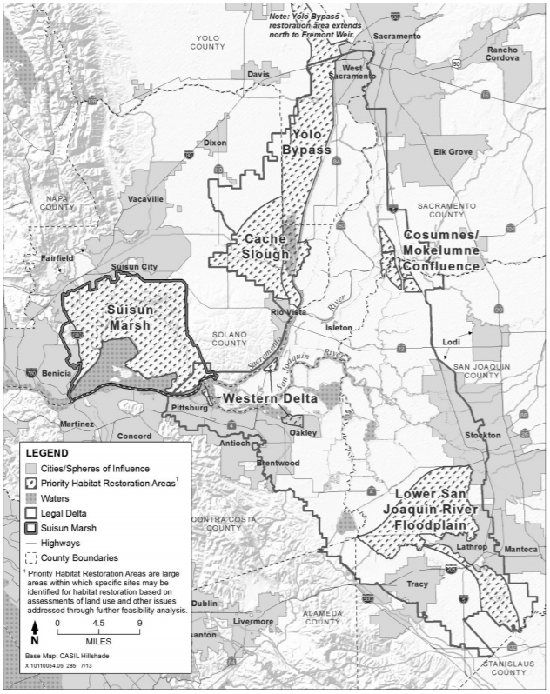
Figure 1. Priority Habitat Restoration Areas (DSC 2013)

Reference
California Department of Water Resources and United States Bureau of Reclamation (DWR and USBR). 2019. Yolo Bypass Salmonid Habitat Restoration and Fish Passage Project Final Environmental Impact Statement/Environmental Impact Report. https://www.usbr.gov/mp/bdo/yolo-bypass.html
Delta Stewardships Council. 2013. Appendix 5 Recommended Areas for Prioritization and Implementation of Habitat Restoration Projects. https://deltacouncil.ca.gov/pdf/delta-plan/2013-appendix-b-combined.pdf

